

**A project Report on**

**JUSTDAIL WEBSITE USING AUTOMATION TOOL SELENIUM WEBDRIVER WITH JAVA.**

**By**

**Vinodhini M**

**Batch-EON (2021-5533)**

**Under the Guidance of,**

**Amurta Deore Kachole**

**(Technical Trainer)**

**EduBridge India Pvt. Ltd.**

**Introduction:**

This Project aims to do overall testing like functional testing, GUI testing on justdail website to check quality of application using selenium web driver. It helps to improve quality of website and saves time for manually doing this testing.

In this project our main focus is to test the autocare module .Auto care is well designed creating website of automative repair shops,Stores with spare parts and accessories for car repairs and other site related to cars and car service.

**Software Requirements:**

Operating System: Windows 8

Browser: Latest version of Google Chrome

Platform: Eclipse IDE

Automation Tool and Language: Selenium WebDriver, Java

Files: JDK, Selenium Jar files, Common IO file

1. **AUTO CARE**

**TC01:** Launch the browser and justdail website

**Selenium WebDriver Test Script:**

System.*setProperty*("webdriver.chrome.driver","C:\\seleniumwebdriver\\chromedriver\\chromedriver.exe");

WebDriver driver=**new** ChromeDriver();

driver.get("https://www.justdial.com/sideMenu");

System.***out***.println("Launching website");

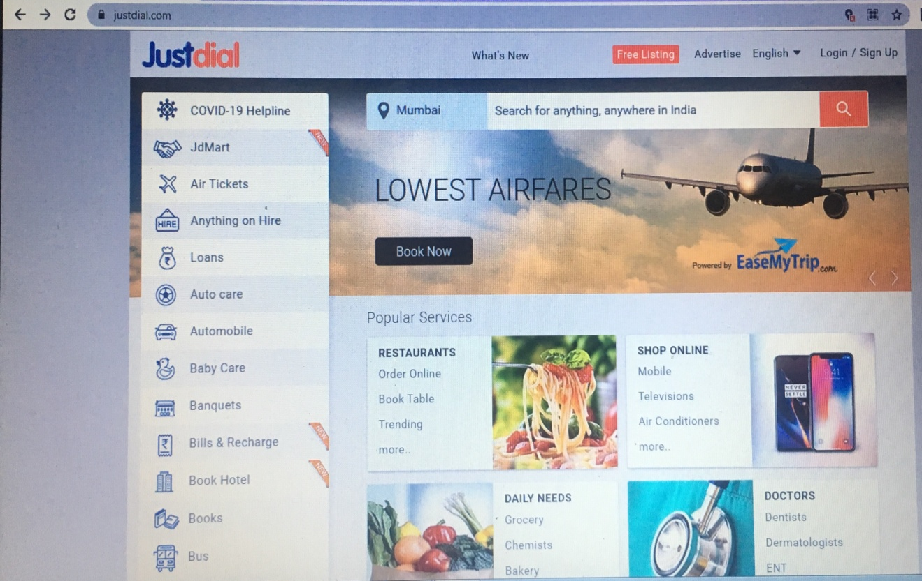

**TC02:** Maximize the window

**Selenium WebDriver Test Script:**

driver.manage().window().maximize();

System.***out***.println("Maximize the window");

**TC03:** To verify and display the auto care

driver.findElement(By.*xpath*("//span[@id='hotkeys_text_5']")).click();

System.***out***.println("checking autocare");

Thread.*sleep*(1000);

JavascriptExecutor js=(JavascriptExecutor) driver;

js.executeScript("window.scrollBy(0, 400)");

Thread.*sleep*(2000); System.***out***.println("Scroll down");

js.executeScript("window.scrollBy(0, -400)");

**TC04:** To verify and display the what are the autocare categorys

**Selenium WebDriver Test Script:**

WebElement drpdown=driver.findElement(By.*xpath*("//body/div[@id='']/div[2]/div[1]/div[2]/ul[1]/li[1]/a[1]"));drpdown.click();

System.***out***.println("checking autocare");

**TC05:** To verify and display the mahendra autocare

**Selenium WebDriver Test Script:**

driver.findElement(By.*xpath*("//*[@id=\"mnintrnlbnr\"]/ul[1]/li[6]/a/span[2]")).click();

System.***out***.println("checking mahendra autocare");

js.executeScript("window.scrollBy(0, 500)");

Thread.*sleep*(2000);

js.executeScript("window.scrollBy(0, 500)");

Thread.*sleep*(2000);

js.executeScript("window.scrollBy(0, 500)");

Thread.*sleep*(2000);

js.executeScript("window.scrollBy(0, 500)");

Thread.*sleep*(2000);

System.***out***.println("scroll up");

js.executeScript("window.scrollBy(0, -2000)");

Thread.*sleep*(2000);

System.***out***.println("Scroll down");

**TC06:** To verify and display the mahendra scorpio

**Selenium WebDriver Test Script:**

driver.findElement(By.*xpath*("//*[@id=\"mnintrnlbnr\"]/ul[1]/li[7]/a/span[2]")).click();

System.***out***.println("checking mahendra scorpio");

Thread.*sleep*(1000);

**TC07:** To verify and display the mahendra scorpio category using scroll by method

**Selenium WebDriver Test Script:**

js.executeScript("window.scrollBy(0, 500)");

Thread.*sleep*(2000);

js.executeScript("window.scrollBy(0, 500)");

Thread.*sleep*(2000);

js.executeScript("window.scrollBy(0, 500)");

Thread.*sleep*(2000);

js.executeScript("window.scrollBy(0, 500)");

Thread.*sleep*(2000);

System.***out***.println("scroll up");

js.executeScript("window.scrollBy(0, -2000)");

Thread.*sleep*(2000);

System.***out***.println("Scroll down");

**TC07:** To verify the navigation go back to previous page.

**Selenium WebDriver Test Script:**

driver.navigate().back();

**TC08:** To verify that browser is able to close.

**Selenium WebDriver Test Script:**

driver.close();